# **5.8 Guided Exercise: Cracking Passwords**

|  |  |
| --- | --- |
| **Resources** | |
| Files | None |
| Machines | Windows 10 |

In this exercise you will use the tool called Ophcrack to crack password hashes.

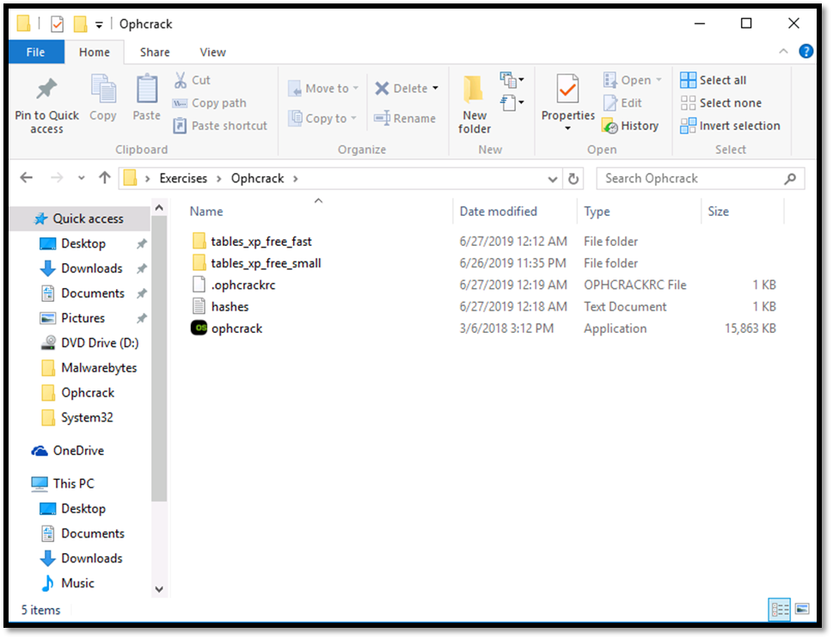Open the desktop folder called Exercises and then the folder Ophcarck.

Double click the file ophcrack to start it. Some rainbow tables are already installed within Ophcrack.

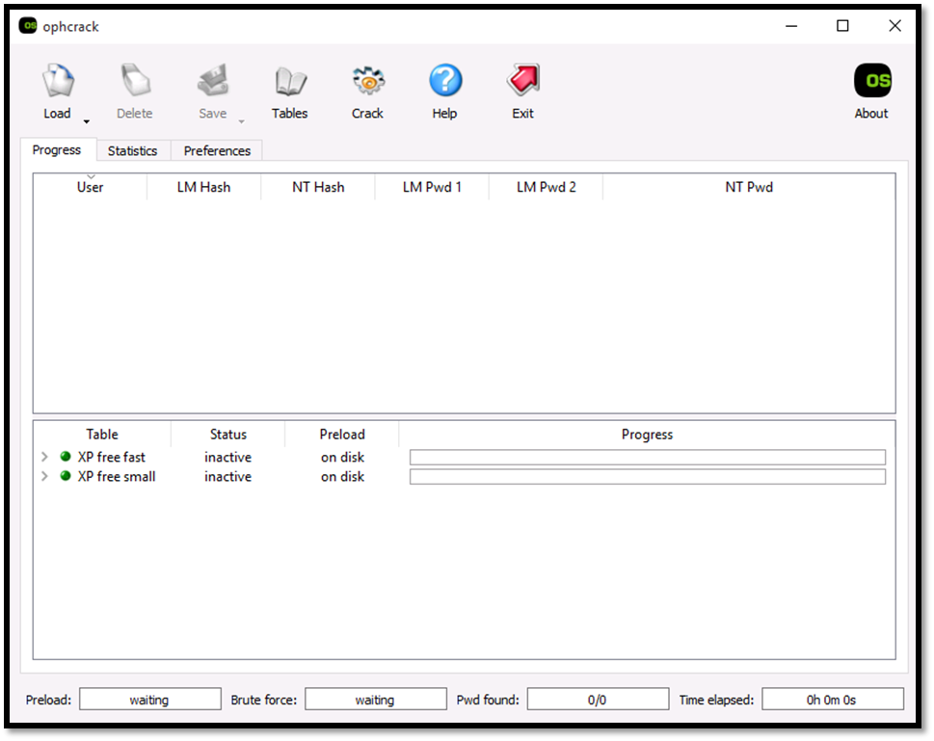

From the Ophcrack folder double click the file hashes to open it.



Once you open the file copy the line that refers to jim.

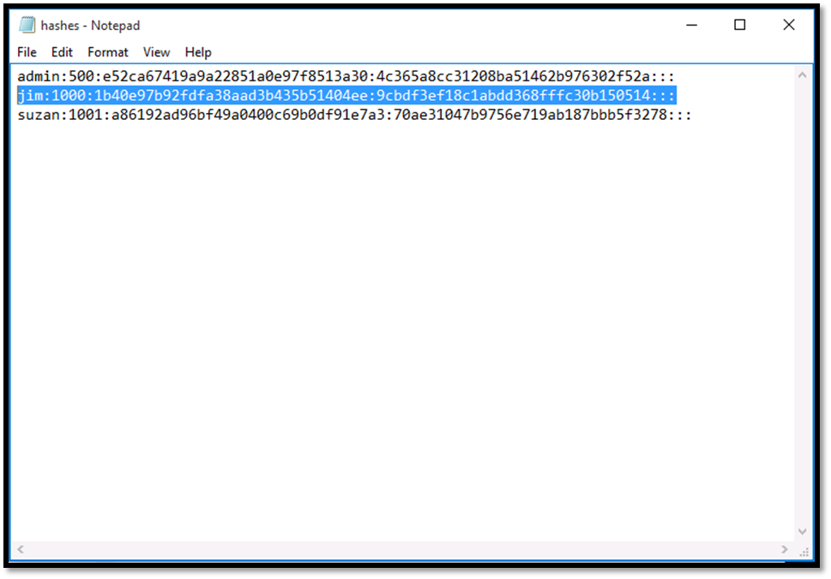

In Ophcrack click Load and then Single hash, paste the hash on Load Single Hash window and then click OK.

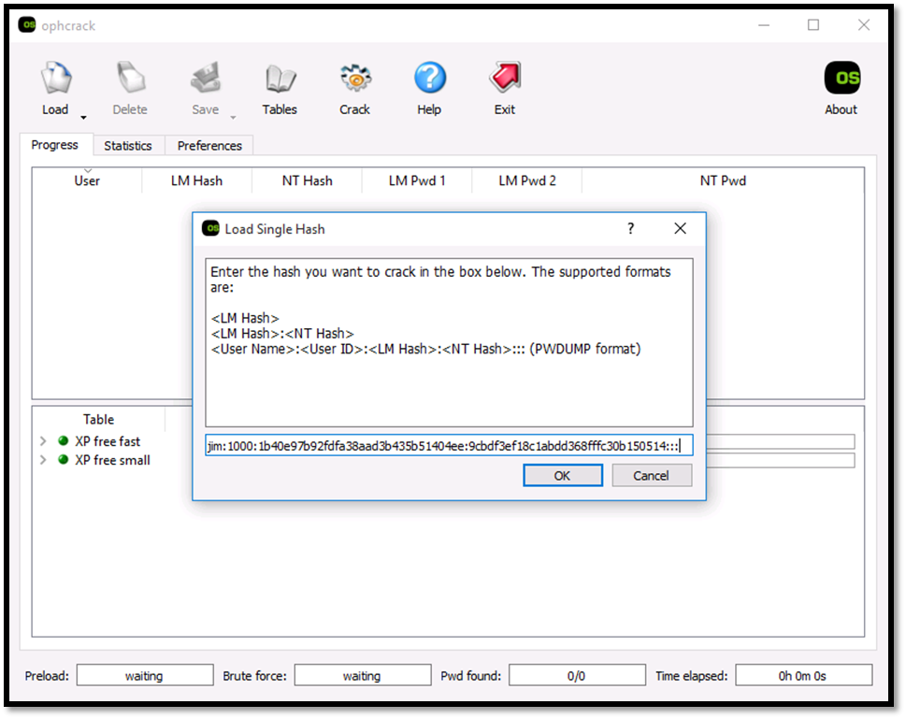

Click Crack to start cracking the password hash. Then you will see the actual password of the user jim.